Azure Devops

Jayanth R

ACE11696

Im creating a project in azure devops as “Aspire_project”

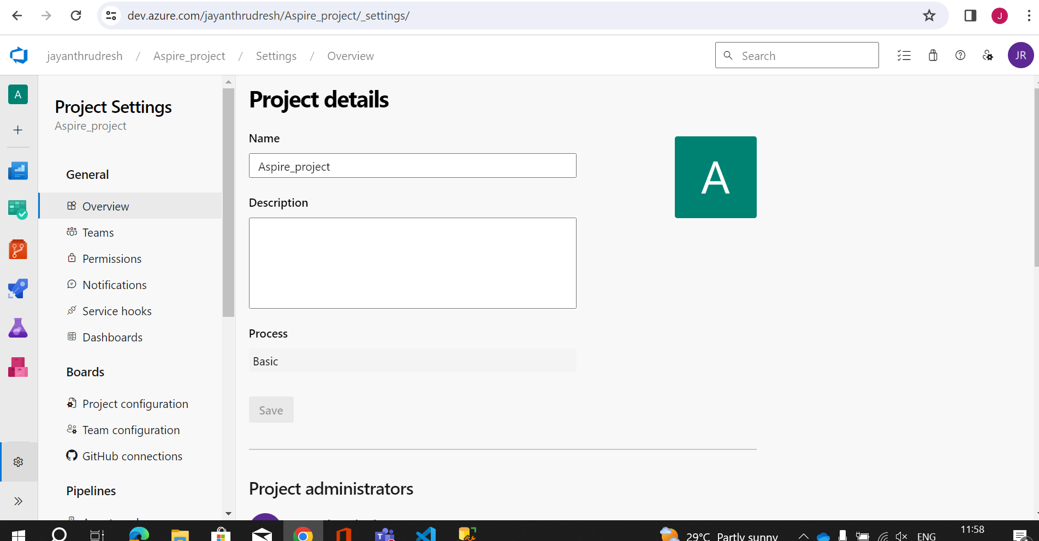

This is the pipeline that i have created for build and test i have used custom pipeline and its in run state.

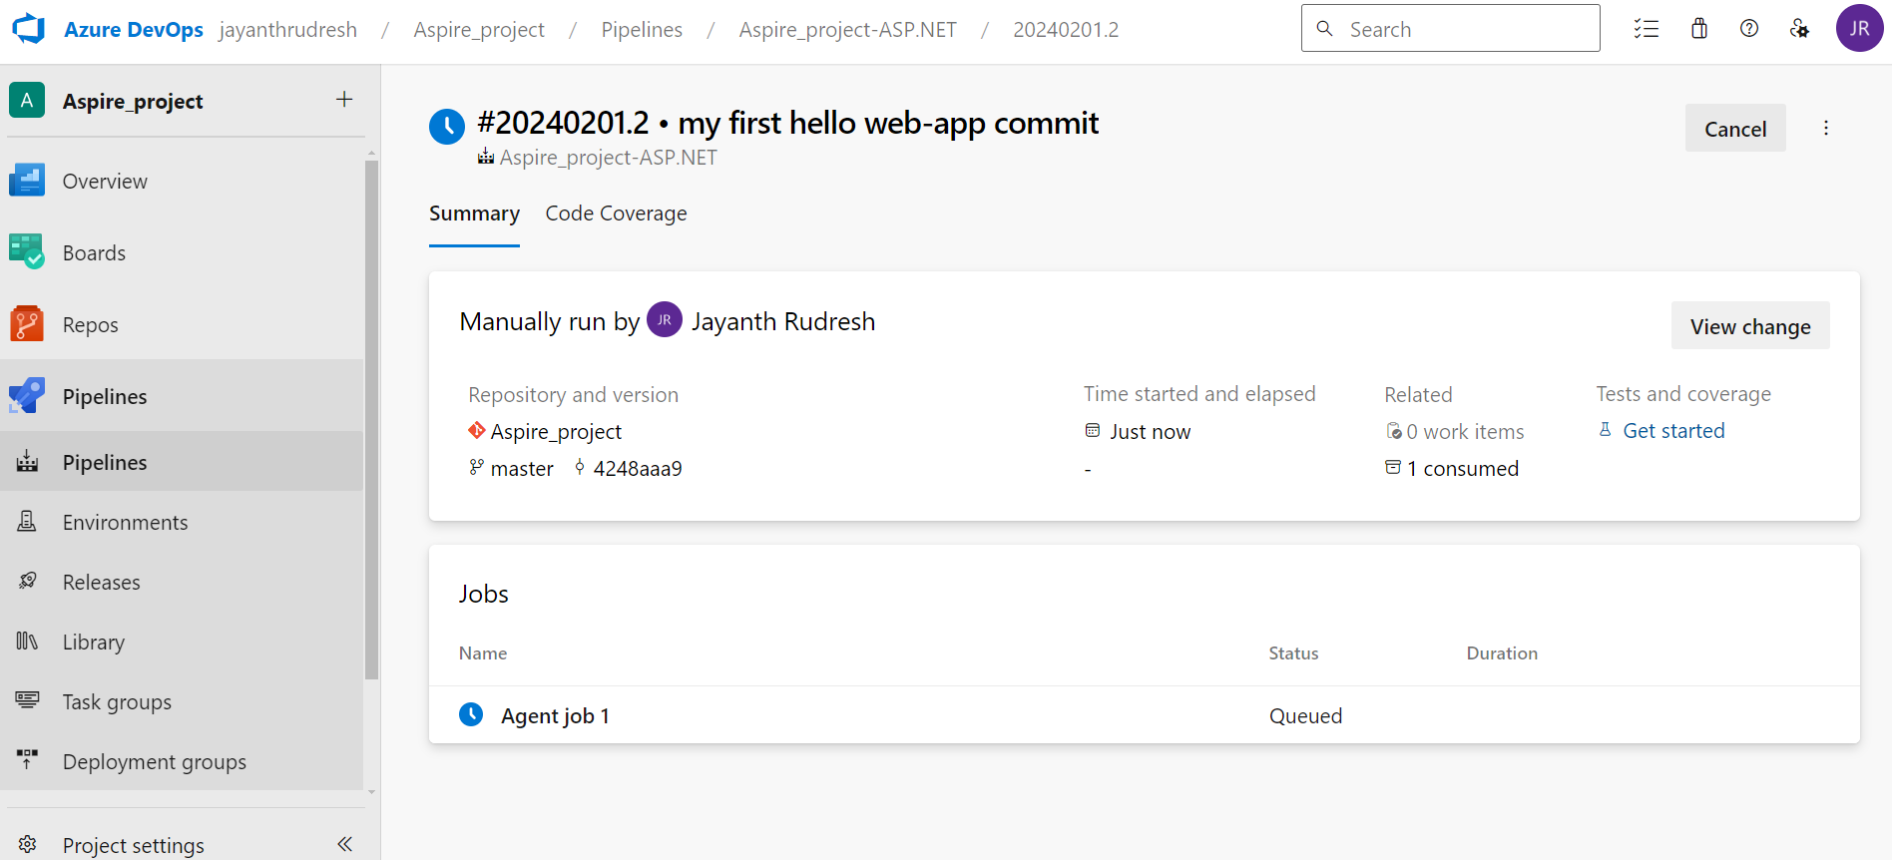

This is the logs seen after the completion of the pipeline.

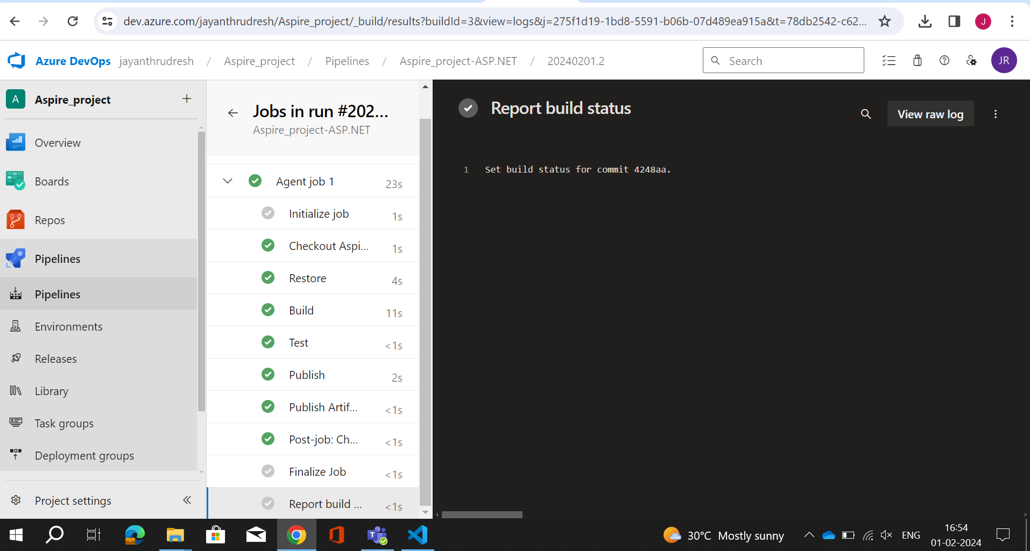

This is the result of my pipeline that is success.

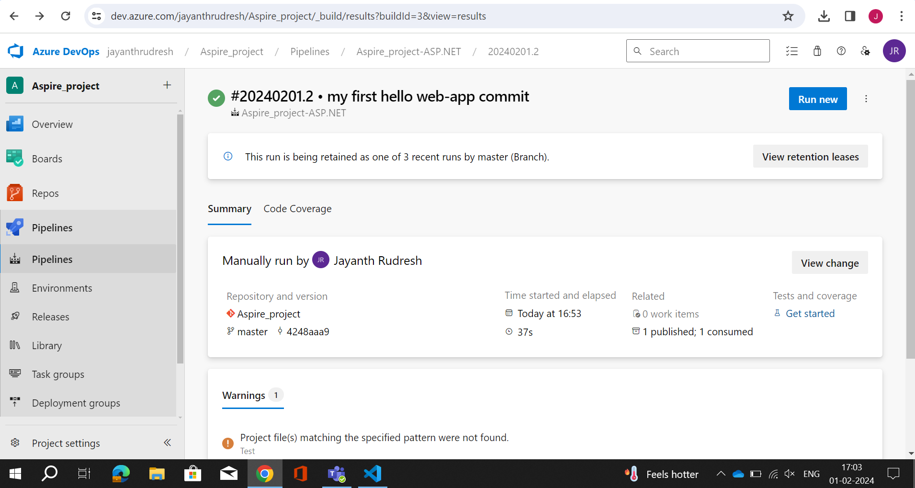

This is the artifact that is stored after the pipeline is successful.

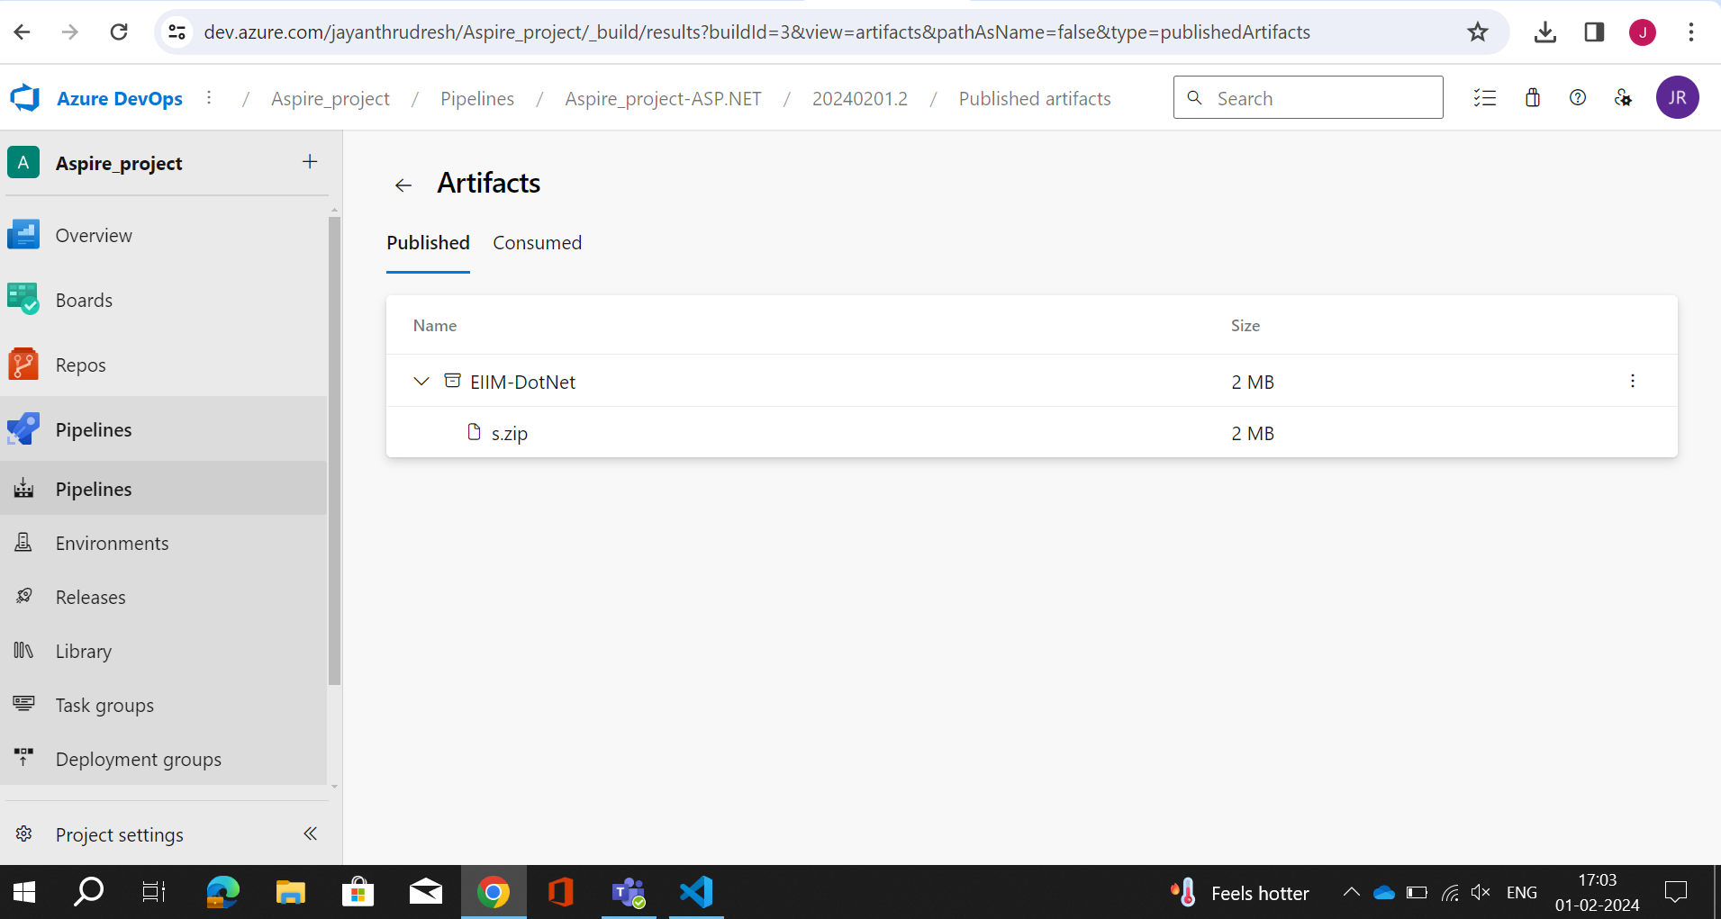

Now we must integrate the azure devops and azure web service that is done in project settings in service connection.

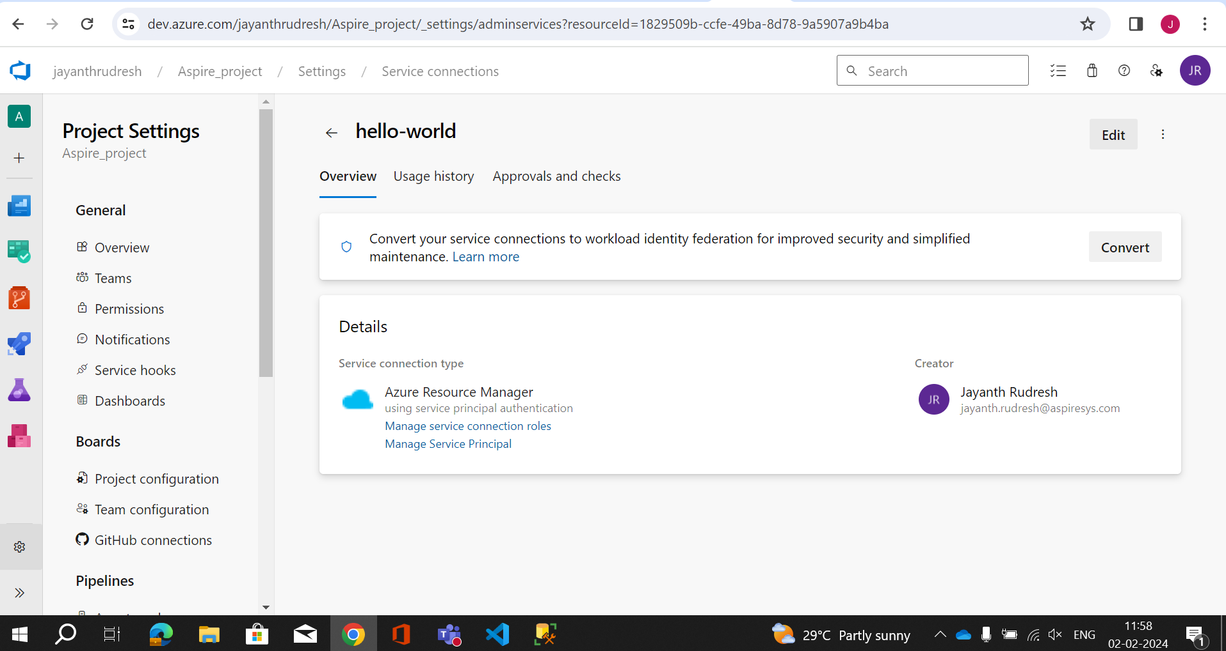

This is the azure web app service that i have created to deploy my web app.

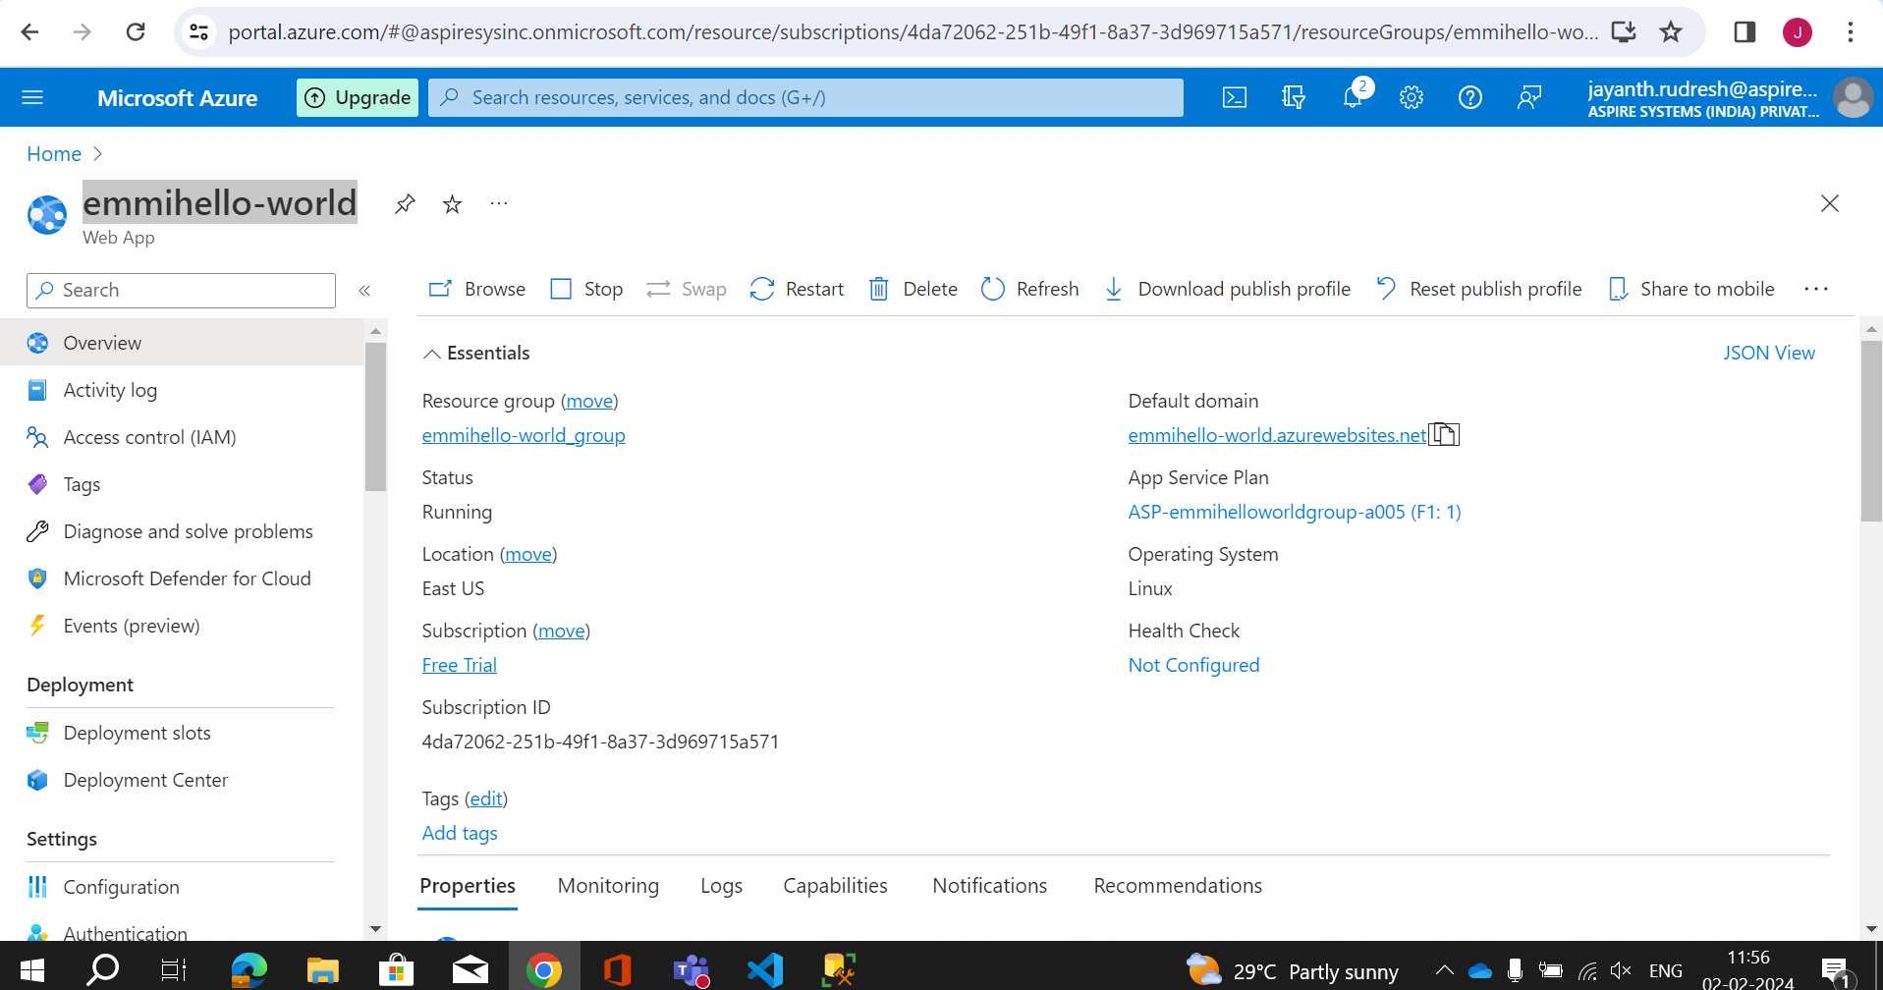

This is the release pipeline that i have created and queued.

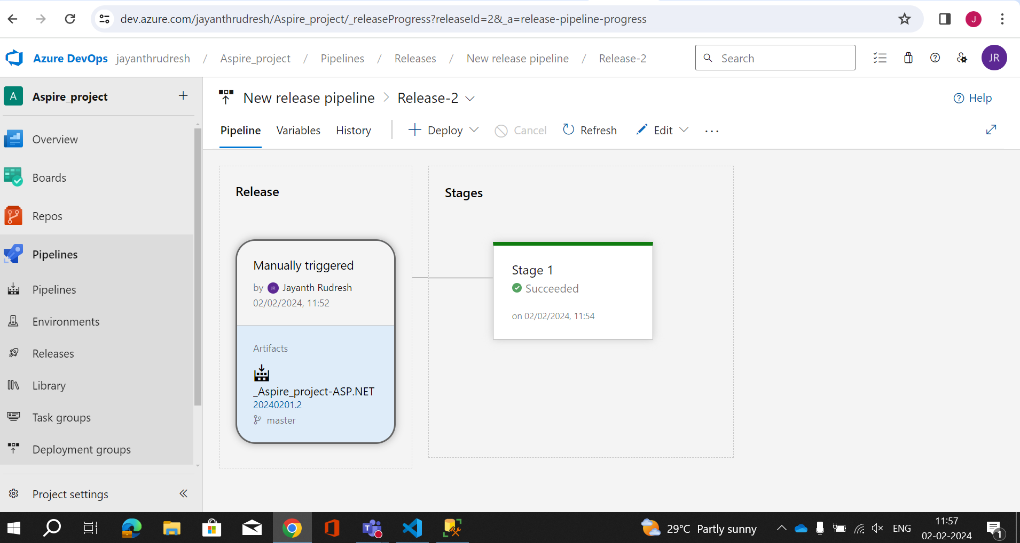

This is the release pipeline which is successful and deployed the web app.

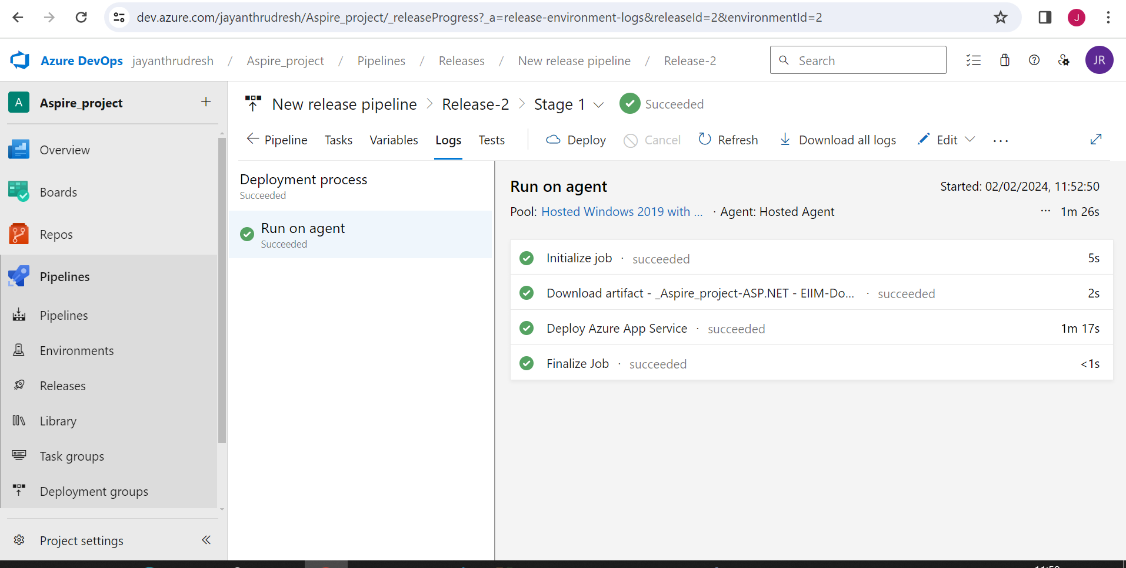

This is the logs of my release pipeline where we will get the link for deployed web app.

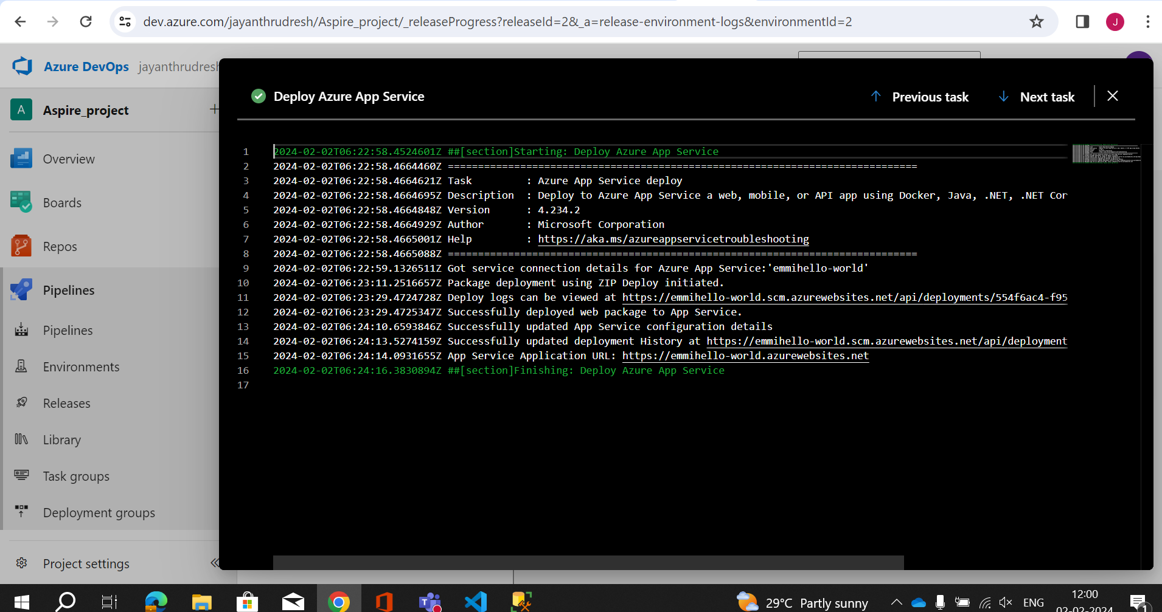

After clicking or navigating to that link we can see our web app deployed.

